PATTERNS IN THE PERIODIC TABLE
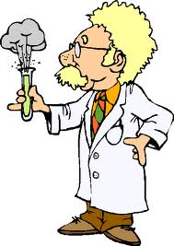
The periodic table is a table of elements.
An element is a pure substance that cannot be broken down into a simpler
chemical substance.
The periodic table is universally used and understood.

Alkali Metals
Alkaline Earth Metals
Halogens
Noble Gases

