PERIODIC TABLE
The periodic table is a table of elements. An element is a pure substance that cannot be broken down into a simpler chemical substance.

An element symbol is an abbreviation for a chemical element.

Some elements on the periodic table have abbreviations that are based on their Latin names and others are based on their English names.
Example: LATIN

ENGLISH

Every element is on the periodic table.
So how can you tell if water is an element?
If you find it on the periodic table, then it is an element.
Anything that is not on the periodic table is not an element and is therefore more complex, and is able to be broken down into a simpler form.

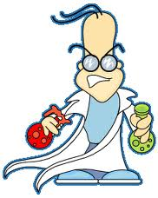

Water was not found on the periodic table so it is more complex. If you run an electric current through water, it produces two gases Hydrogen and Oxygen (both of which are found on the periodic table).

Any pure substance that is composed of two or more different elements that are chemically joined is called a COMPOUND.

Water is a compound made up of the elements hydrogen and oxygen.

Elements are the building blocks of all substances. Within the periodic table there are underlying patterns that make it a very useful tool.

