PUTTING ATOMS TOGETHER
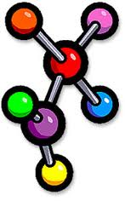

Molecular Elements
- A molecule consisting of atoms of the same element. Therefore not a compound.

Molecular Compounds
- A molecule that consists of 2 or more different elements.

Ionic Compounds
- A compound that consists of positively and negatively charged ions.

