**Testing for Gases**

1. Oxygen gas

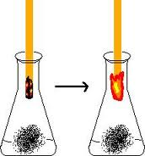

1. Carbon dioxide gas

[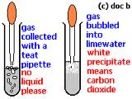](http://www.google.ca/imgres?q=testing+for+carbon+dioxide+with+limewater&um=1&hl=en&biw=1366&bih=673&tbm=isch&tbnid=XONvnIr6fH3E-M:&imgrefurl=http://www.docbrown.info/page13/ChemicalTests/ChemicalTestsg.htm&docid=7yMcpRizF1n9bM&imgurl=http://www.docbrown.info/page13/ChemicalTests/CO2test.gif&w=201&h=150&ei=CMF1UOutKsTk0QG24YGABA&zoom=1&iact=hc&vpx=739&vpy=198&dur=243&hovh=120&hovw=160&tx=59&ty=91&sig=106391495954961825574&page=3&tbnh=120&tbnw=160&start=44&ndsp=24&ved=1t:429,r:3,s:44,i:221)

1. Hydrogen gas

[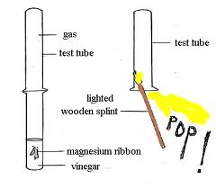](http://www.google.ca/imgres?q=testing+for+hydrogen+gas+using+a+splint&um=1&hl=en&biw=1366&bih=673&tbm=isch&tbnid=6M04CGOELBSeVM:&imgrefurl=http://www.courseworld.com/sci10/labs/hydrogen.html&docid=9XtPHwogkjojfM&imgurl=http://www.courseworld.com/sci10/labs/pop1.gif&w=400&h=350&ei=osB1ULipF6X00gHwtIHYDA&zoom=1&iact=hc&vpx=386&vpy=146&dur=179&hovh=210&hovw=240&tx=151&ty=121&sig=106391495954961825574&page=1&tbnh=148&tbnw=167&start=0&ndsp=18&ved=1t:429,r:1,s:0,i:71)